**CSE3011 NETWORK PROGRAMMING**

**LAB EXPERIMENT 10**

NAME – B PRATYUSH

REGISTRATION NUMBER – 19BCN7114

FACULTY – PROF. MUNEESWARI

**Experiment Description: UDP Client Server Communication program using Datagram**

**CODE:**

**udpClient.java**

import java.util.*;

import java.io.IOException;

import java.net.DatagramPacket;

import java.net.DatagramSocket;

import java.net.InetAddress;

public class udpClient {

public static void main(String[] args) throws IOException {

Scanner sc = new Scanner(System.in);

DatagramSocket ds = new DatagramSocket();

InetAddress ip = InetAddress.getLocalHost();

byte buf[] = null;

while (true)

{

String inp = sc.nextLine();

buf = inp.getBytes();

DatagramPacket DpSend = new DatagramPacket(buf, buf.length, ip, 1234);

ds.send(DpSend);

// break the loop if user enters "bye" if (inp.equals("bye"))

break;

}

sc.close();

ds.close();

}

}

**udpServer.java**

import java.io.IOException;

import java.net.DatagramPacket;

import java.net.DatagramSocket;

import java.util.*;

public class udpServer {

public static void main(String[] args) throws IOException {

// TODO Auto-generated method stub

DatagramSocket ds = new DatagramSocket(1234);

byte[] receive = new byte[65535];

DatagramPacket DpReceive = null;

while (true)

{

DpReceive = new DatagramPacket(receive,receive.length);

ds.receive(DpReceive);

System.out.println("Client Says:-" + data(receive));

Arrays.fill(receive,(byte)0);

if (data(receive).toString().equals("bye"))

{

System.out.println("Client sent Bye!!EXITING");

break;

}

}

ds.close();

}

public static StringBuilder data(byte[] a)

{

if (a == null)

return null;

StringBuilder r = new StringBuilder();

int i = 0;

while (a[i]!= 0)

{

r.append((char)a[i]);

i++;

}

return r;

}

}

**Outputs**

**Client side**

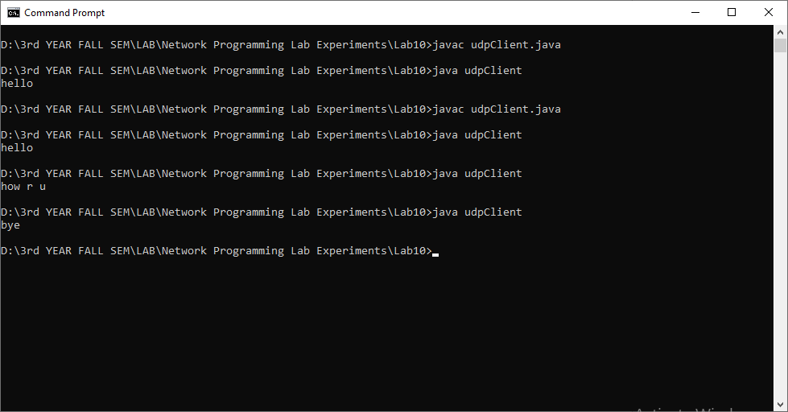

**Server Side**

